Graphical Processing Systems

Project Documentation

Student : Ungureanu Florin-Catalin

Group : 30434

Advisor :Nandra Cosmin

1. Contents

1. Contents

2. Subject specification

3. Scenario

3.1. scene and objects description

3.2. functionalities

4. Implementation details

4.1. functions and special algorithms

4.2. graphics model

4.3. data structures

4.4. class hierarchy

5. Graphical user interface presentation / user manual

6. Conclusions and further developments

7. References

1. Subject specification

The subject of this project is the photorealistic presentation of 3D objects using OpenGL library. The user directly manipulates by mouse and keyboard inputs the scene of objects.

The scene I presented is a secret canyon military base. The camera can be moved around the scene by using the keyboard, while some of the objects can also be manipulated by using the keyboard.

1. Scenario
   1. Scene and objects description

In a distance future far far away, the most evolved nation had a mission to hide a secret weapon, a nuclear rocket.In a big canyon , using only a watchtower and some tents alongside a few resources such as a woods and oil reservoir.

* 1. Functionalities

The main source of light is the sun and the directional light. The tank can be moved along the scene with the keyboard keys by the user. The eagle is moving by itself, while inspecting the canyon. The rocket can take off. The user can take a tour of the scene by pressing the keyboard keys or the mouse. One can also switch between solid view and wireframe or polygonal and smooth face using keyboard keys. Fog also appears by the choice of the user and it can disappear .

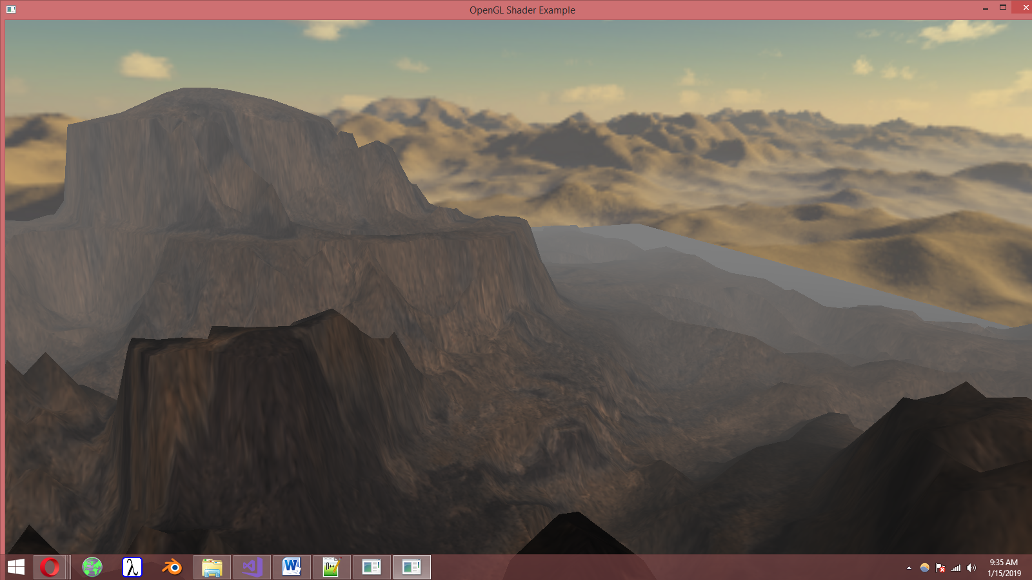

float computeFog()

{

float fogDensity = 0.010f;

float fragmentDistance = length(fragPosEye);

float fogFactor = exp(-pow(fragmentDistance * fogDensity, 2));

return clamp(fogFactor, 0.0f, 1.0f);

}

Translating and rotation

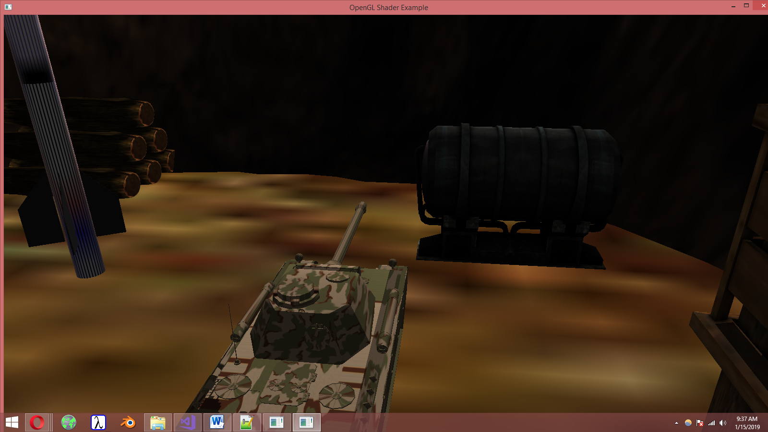

Lauching the rocket

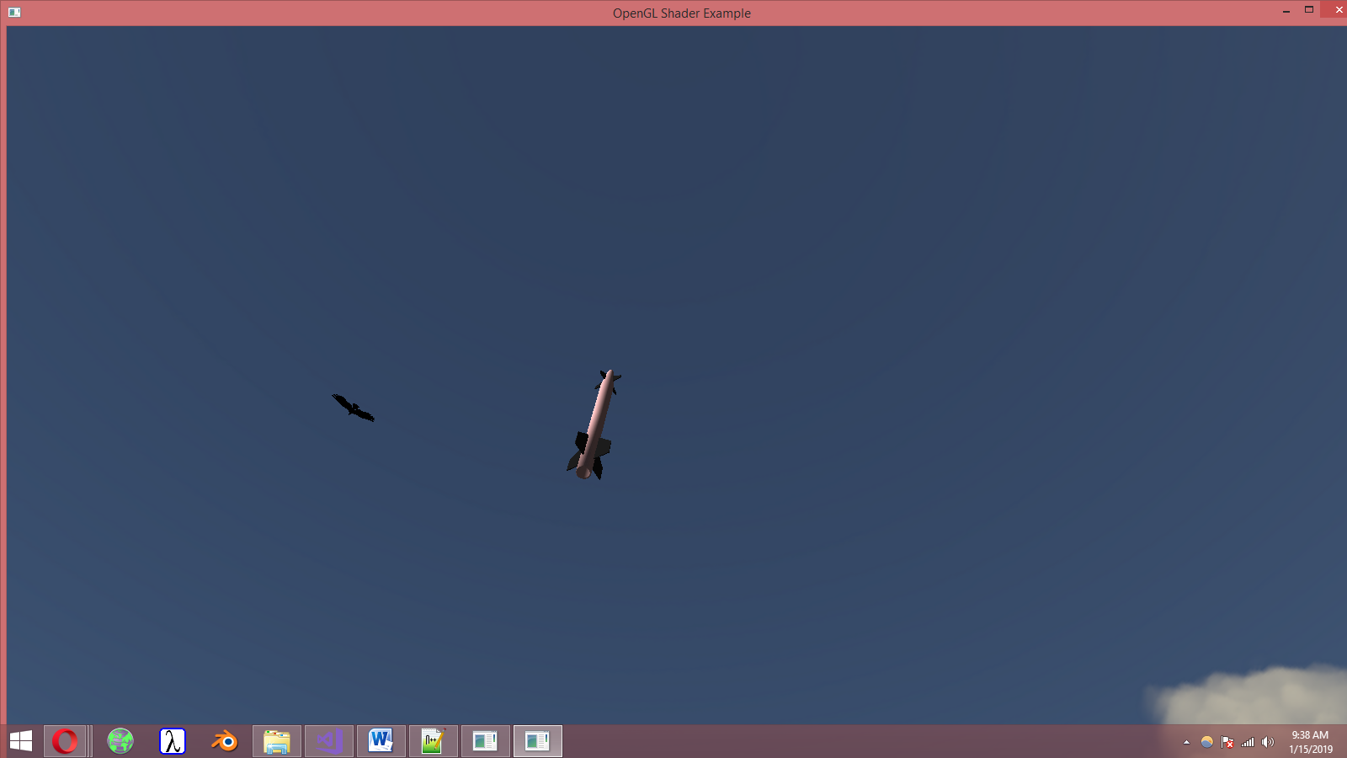

Traspharency after 100 m . Rocket speed is calculetated by v = v0 + a*t ;

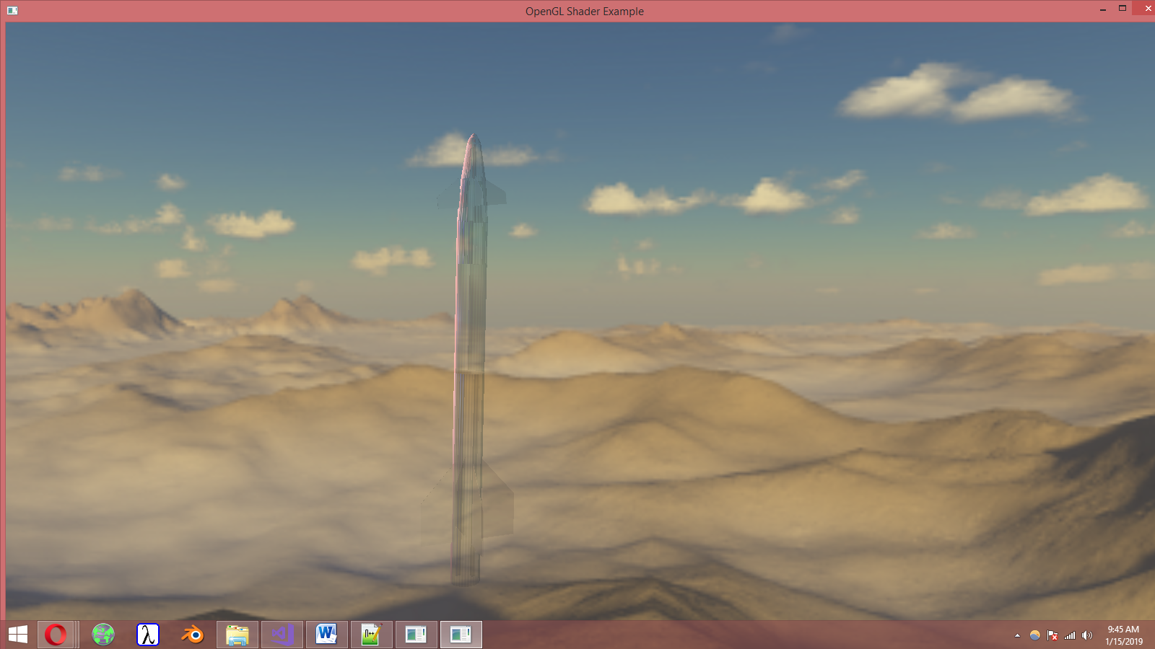

Wireform

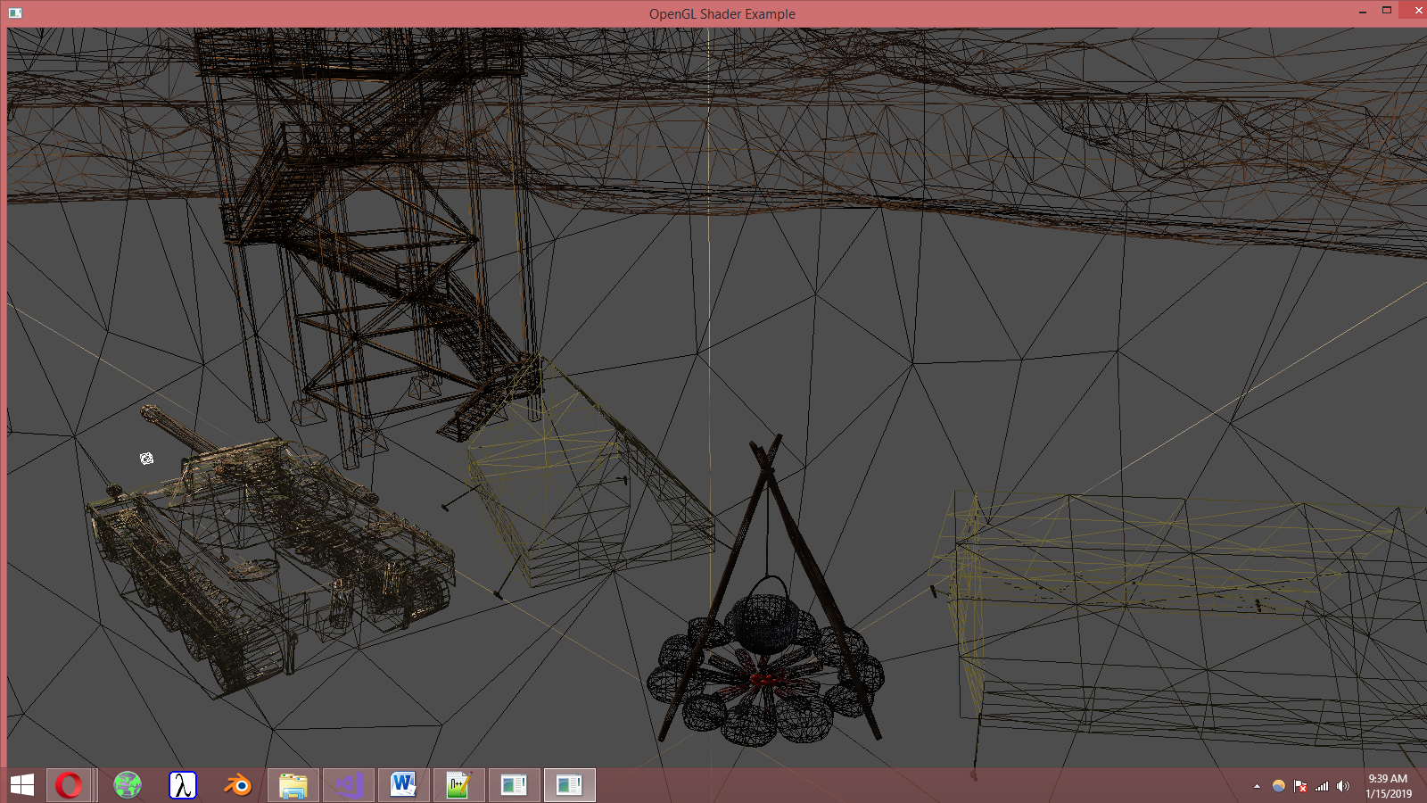

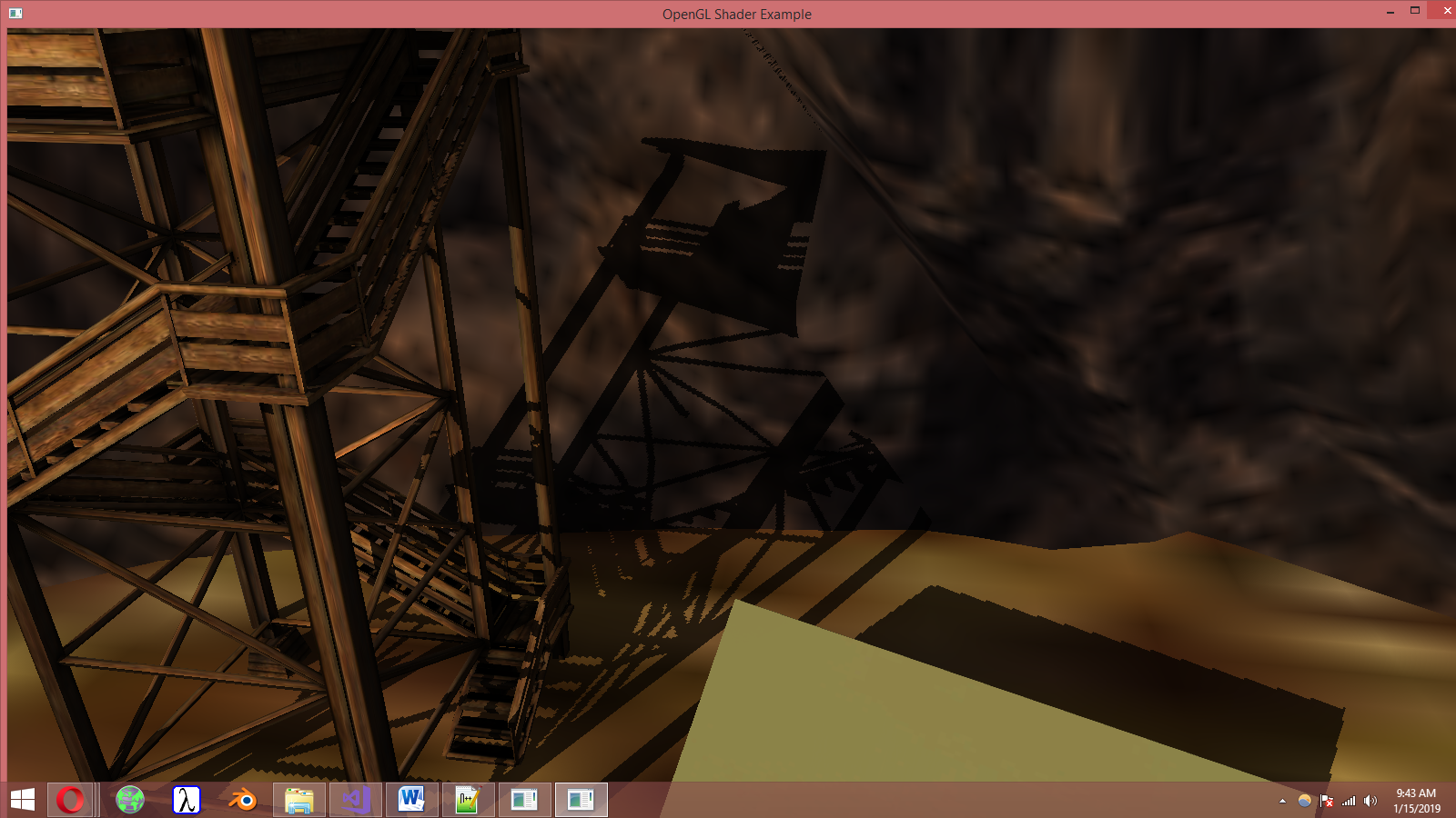

1. Implementation details
   1. Functions and special algorithms

OpenGL library consists in a large variety of functions such as glViewport(…) used for setting Viewport transform, glfwCreateWindow(…) used for creating the window, glGenTextures(…), glBindTexture(…), glTextImage2D(…) used for creating depth texture for the Framebuffer objects and many others.

One of the functions I’ve used in this project is void renderScene() which is the function used to send all the data to the shaders and compute all the values, here is where all the models and their shadows are created, here is where the normal matrix are computed and where the rotation, translation and scaling are done. Another function is void initUniforms() where the lights’ details are all set – the point light, the light direction and the light color. The function void initShaders() is a function where the shaders are instantiated and the function void initModels() is a function where all the 3D Models are instantiated as well. Another important functions are the void processMovement(), void move(gps::MOVE_DIRECTION direction, float speed), void mouseCallback(GLFWwindow* window, double xpos, double ypos) and void keyboardCallback(GLFWwindow* window, int key, int scancode, int action, int mode) functions, which performs all the necessary changes on the models or on the camera so that they perform the moves desired by the user.

A skybox is used in order to define the surroundings of the scene. The mouseCallBack function is implemented by using Euler Angles. A mathematics library tailored for OpenGL – GLM – is also used in order to implement the functions and the algorithms.

* 1. Graphics model

The objects from the scene are 3D Models under the .obj extension which were found online at <https://free3d.com> , <https://www.turbosquid.com> or other similar webpages. The scene was constructed by using Blender.

* 1. Data structures

The fragment shader defines the light structures and shadow computation so that the only newly data structures used were those predefined in the header files “glm.hpp”, “glfw.h”, “glew.h” and the other OpenGL libraries. For example, I have used the MOVE_DIRECTION defined enum structure in order to simplify the movement of models in the user’s desired direction.

* 1. Class hierarchy

The project’s class hierarchy is defined by the libraries used and by the shaders. The files Mesh.cpp and Model3D.cpp are used for the objects’ definition and for applying textures on objects. The file Shader.cpp is the one which makes compilation of the shaders possible and which provides the loading and linking step of shaders to the main program. Camera.cpp is a file where the movements are done on the camera.

1. Graphical user interface presentation/user manual

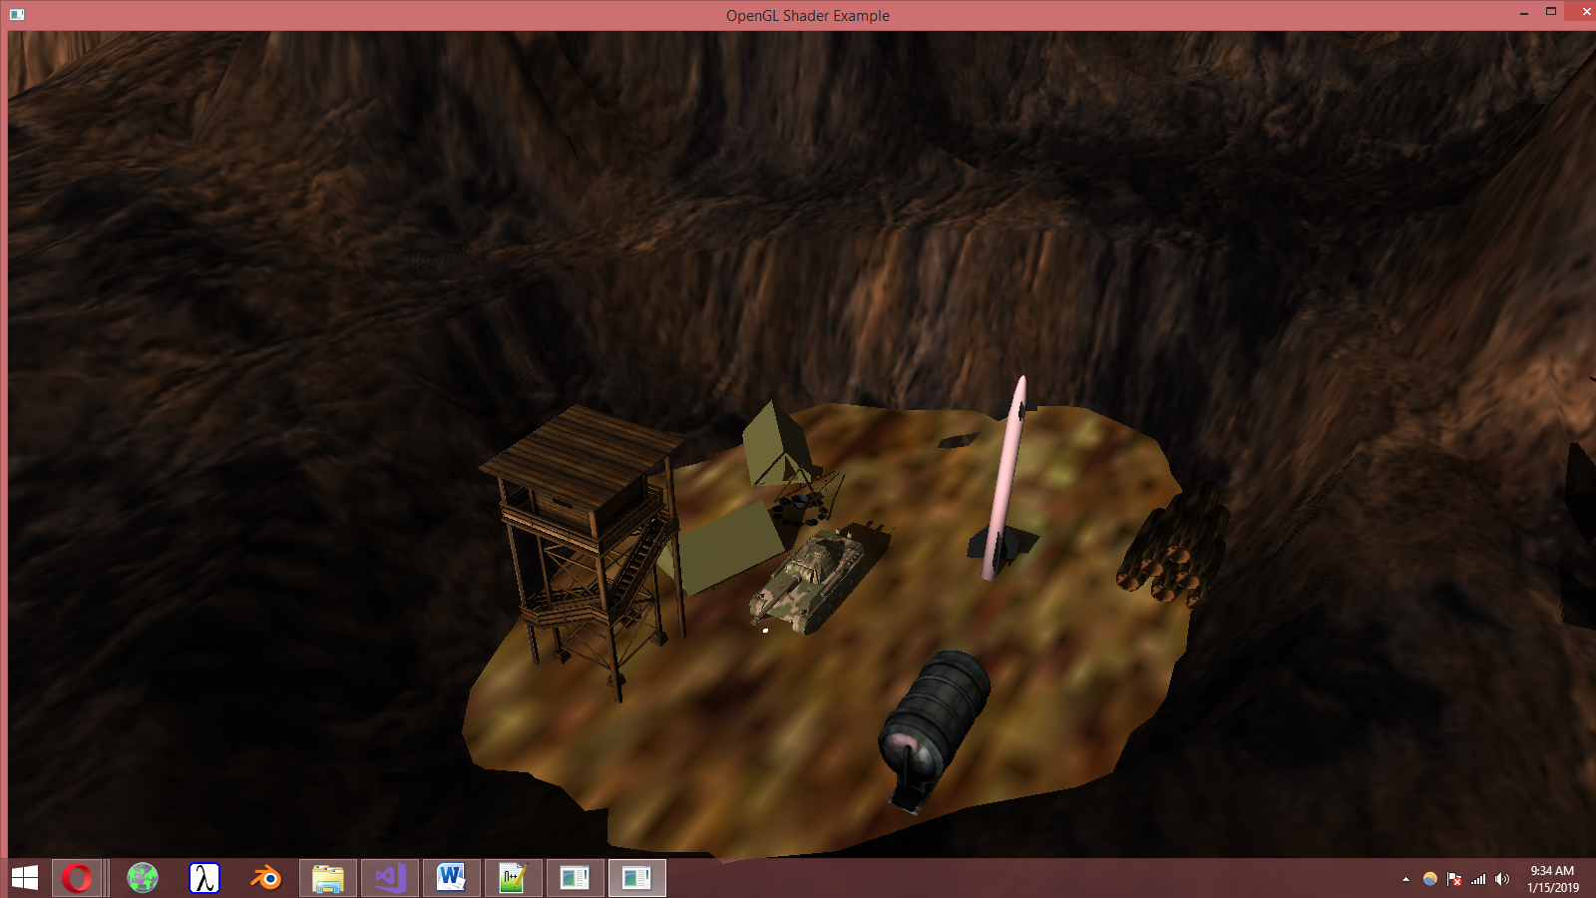

The user can perform the following functions on the scene or on the objects in the scene by using the following keyboard keys:

* W – zoom in – move the camera forward
* S – zoom out – move the camera backward
* A – move the camera to the right
* D – move the camera to the left
* Q – rotate the camera to the right
* E – rotate the camera to the left
* K – move the light to the left
* L – move the light to the right
* X – show wireframe view
* F – show the fog
* G – make the fog disappear
* C –launch the rocket
* Up – move the tank backward

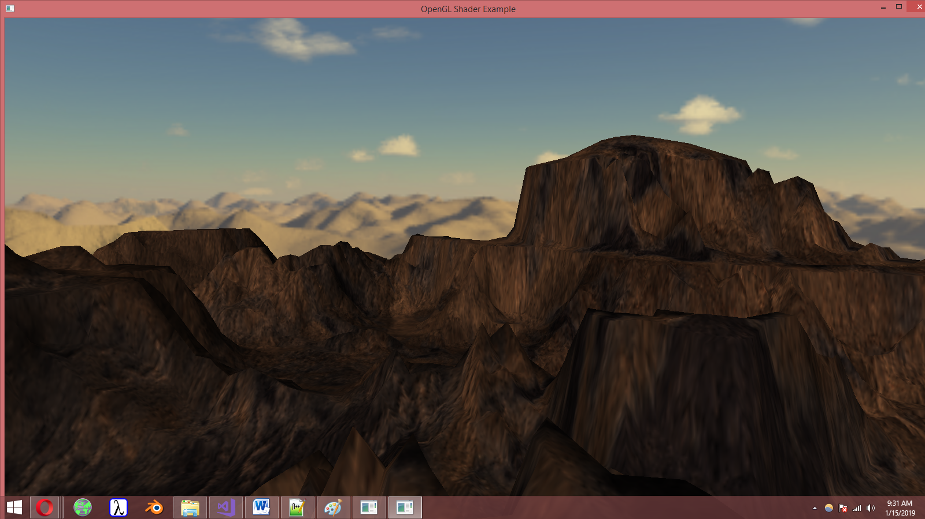

* Down – move the tank forward
* Left – move the tank to the left
* Right – move the tank to the right

The camera can also be moved by using the mouse.

1. Conclusions and further developments

This project’s purpose was to introduce the students into working with OpenGL, 3D models, using specific libraries and different tools for 3D modelling such as Blender.

1. References

1. http://cgis.utcluj.ro/teaching

2. https://learnopengl.com

3. <http://www.opengl-tutorial.org/>

4. http://tf3dm.com/

5. <https://www.cgtrader.com>

6. <https://free3d.com>

7. <https://turbosquid.com>